Task #1
Name: Mrs. Shital Talokar
Challenge: Problems faced by students in understanding and memorizing the internal structure of heart.
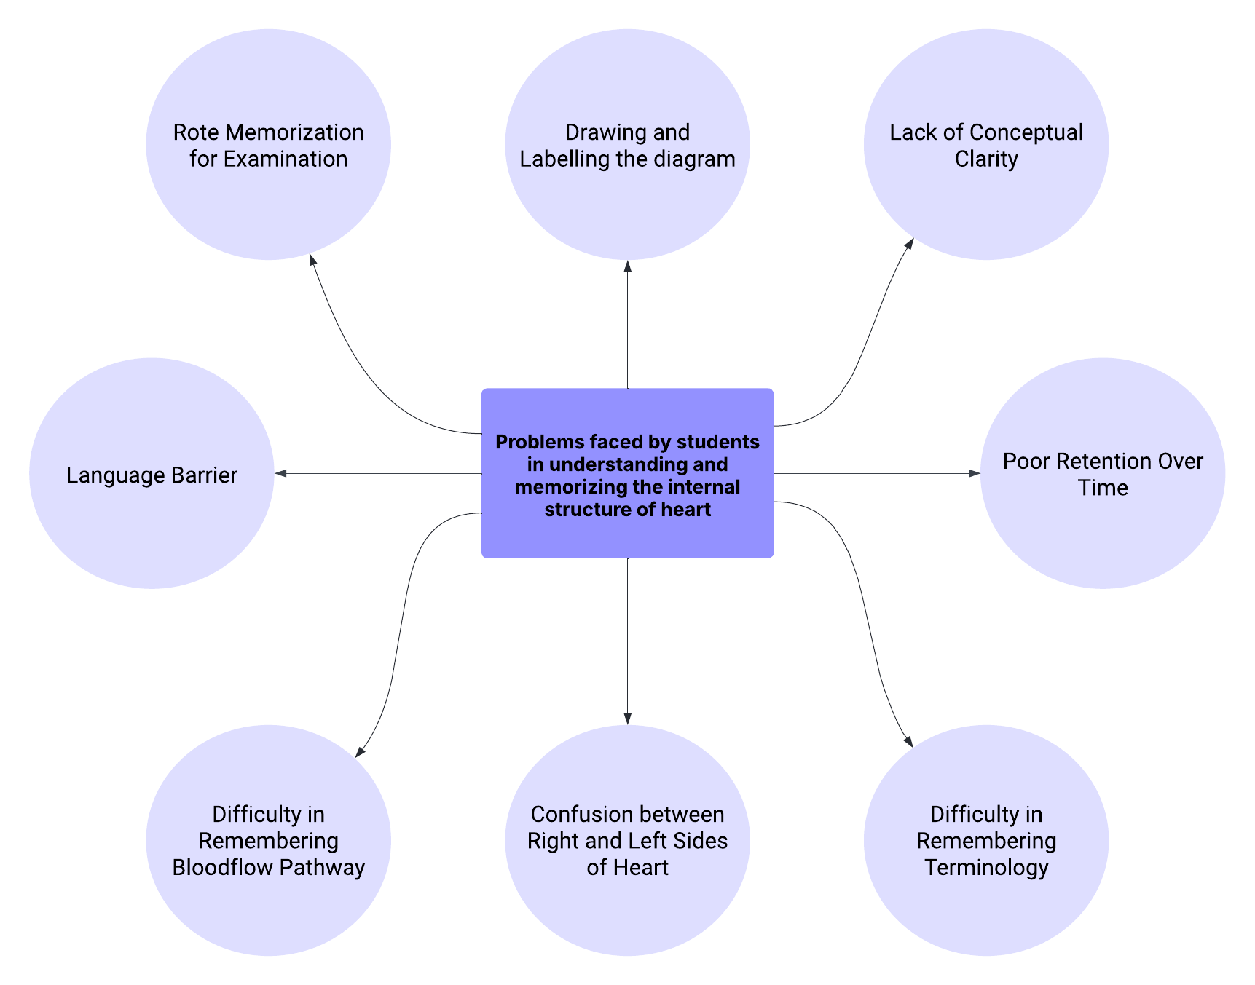
https://lucid.app/lucidspark/26c858c2-1887-4bdc-b32f-ab0658c9e74b/edit?viewport_loc=-676%2C-364%2C3840%2C1896%2CPwWj5IEwLxWS&invitationId=inv_acba2c67-b94b-4055-aabc-44c31ae72eb4

